DIS-Taino-Fossil Coral

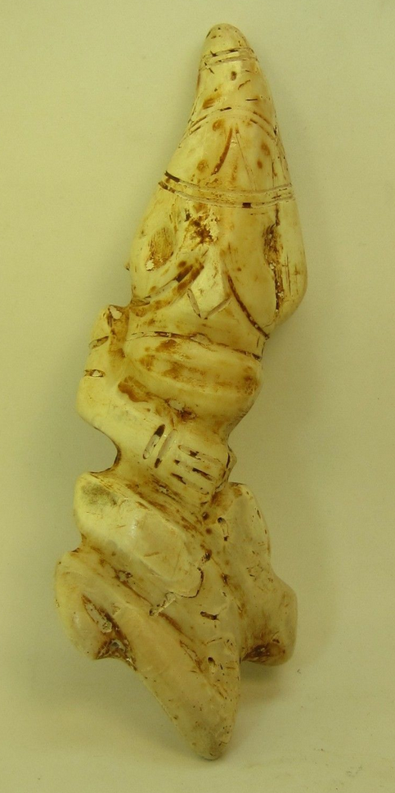 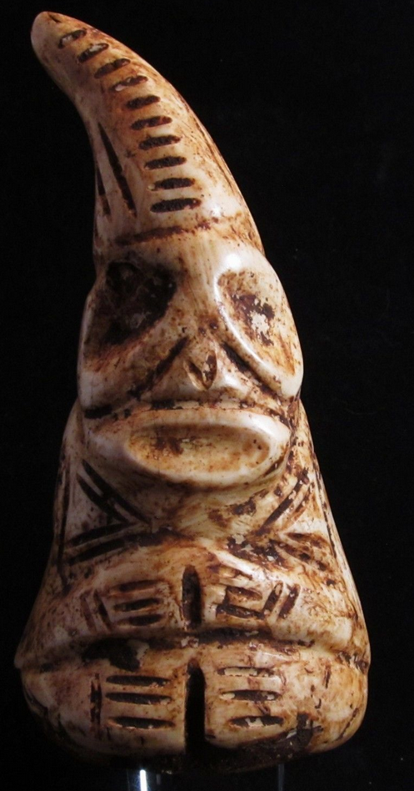

Left: Shaman as amulet with distinctive pointed cap, Puerto Rico, Fossilized coral, 6.5 inches long x 2.5 inches wide. Atlantika coll. Right: Dominican Republic (?), Shaman as amulet with distinctive pointed cap, Fossilized shell, ca. inches long 4.75 x 1.25 inches wide, private collection, valued $1200. Another example is found in Larry Roberts, Taino Sculpture: Art of the Gods (Micanopy FL, 2014), p. 27, Fig. 150.

